**Practical No. 20: Develop a program to import different classes in package.**

1. **Practical Significance:**

Packages are collection of classes and interfaces. Importing of Packages which helps in Reusability. Better organization of the classes and interfaces helps in resolving the name conflicts.

1. **Relevant Course Outcome:**

Apply concept of inheritance for code reusability.

1. **Practical Outcome:**

Develop program to import different classes in package.

1. **Minimum Theoretical Background:**

**What is Package?**

It is a collection of similar types of **classes, interfaces** and **sub-packages**.

Packages are categorized in two form, **built-in package** and **user-defined package.**

**Frequently Used API Packages**

**Using System Packages**

Java

Color

Graphics

Font

Image

awt

Package containing awt package

Package containing class

Classes containing methods

awt

**Hierarchical represents of java.awt package**

**Accessing the classes stored in a packages:**

**Method 1: Using import Statements:**

The first method is to use the **Fully qualified class name** of the class:

import packagename.Classname;

**Example:**

import java.lang.Math;

This statement imports the class Math and therefore class name can be used directly. It is not necessary to use the package name to qualify the class.

import java. lang. Math. sqrt(x);

Method name

Class name

Package name

**Method 2: Shortcut Approach**

import packagename.*;

import java.lang.*;

This statement imports **every class** contained in the specified package.

Above statement will bring **all the classes** of java.lang package.

**Creating Packages**

package PackageName; //package declaration

public class FirstClass //class definition

{

body of class

}

**Package Hierarchy**

Package firstPackage.secondPackage;

**Accessing a Package**

A java system package can be accessed either using a **fully qualified class name** or using a **shortcut approach** through the import statement.

**Syntax:**

import package1[.package2] [.package3].classname;

package1 is the name of the **outer package,** package2 is the name of the package that is **inside the package1.**

Package hierarchy consists of any number of packages. Finally the explicit classname is specified.

**Example:**

import firstPackage.SecondPackage.Myclass; //fully qualified class name

**OR:**

import packagename.*;

import firstPackage.*; //shortcut approach

1. **Program Code:**

package pack;

public class NewPack

{

public void name()

{

System.out.println("Aniket");

}

}

import pack.*;

class Show

{

public static void main(String args[])

{

NewPack np = new NewPack();

np.name();

}

}

1. **Result:**

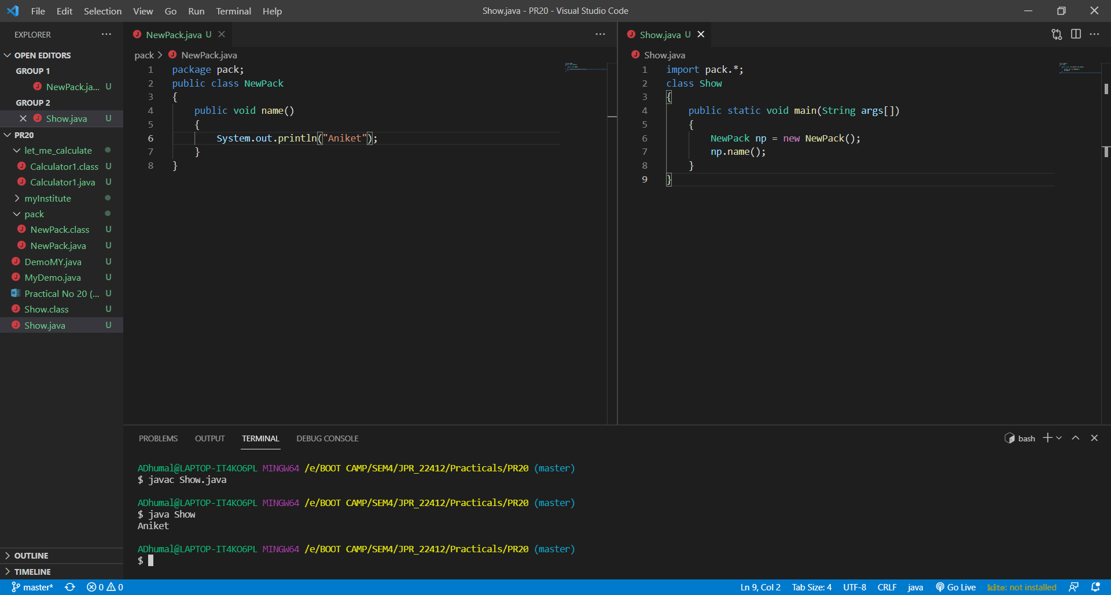

1. **Practical Related Questions:**
2. **Name some of java packages.**
3. java.applet
4. java.awt
5. java.io
6. java.lang
7. java.math
8. java.net
9. java.util
10. **Can we import same class/package twice? Will the JVM load the package twice at run time?**

One can import the same package or same class multiple times. Neither compiler nor JVM complains about it. And the JVM will internally load the class only once no matter how many times you import the same class.

1. **Write fully qualified and shortcut class naming approach with example.**

A fully-qualified class name in Java contains the package that the class originated from. An example of this is java.util.ArrayList.

1. **Exercise:**
2. **The code uses the class defined below. Class Importclass is not defined in circle folder. Will the code run without giving any errors?**

**import circle.NewCircle;**

**class ImportClass**

**{**

**public static void main(String[] args)**

**{**

**circle.NewCircle nc = new circle.NewCircle();**

**System.out.println("Hello Java");**

**}**

**}**

The code will not run it gives error.

1. **Define a package named myInstitute include class named as department with one method to display the staff of that department. Develop a program to Import this package in a java application and call the method defined in the package.**

package myInstitute;

public class Department

{

public void display()

{

System.out.println("Total number of Staff in Department is : 5 ");

}

}

import myInstitute.*;

class MyDemo

{

public static void main(String args[])

{

Department d = new Department();

d.display();

}

}

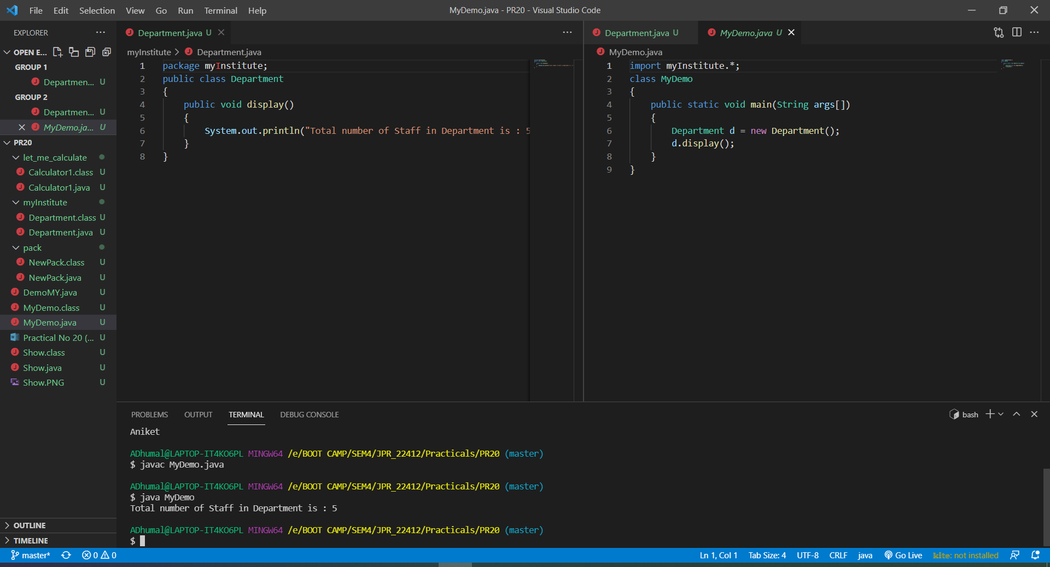

1. **Develop a program which consists of the package named let_me_calculate with a class named calculator and a method named add to add two integer numbers. Import let_me_calculate package in another program (class named Demo) to add two numbers.**

package let_me_calculate;

import java.util.*;

public class Calculator1

{

public void add()

{

Scanner sc = new Scanner(System.in);

int a = sc. nextInt();

int b = sc. nextInt();

System.out.println("Addition = " + (a + b));

}

}

import let_me_calculate.*;

class DemoMY

{

public static void main(String[] args)

{

Calculator1 c = new Calculator1();

c.add();

}

}

